When I used the pog name it put the active pog name on all the pages….Why?

If you are using a Formula area to display Name(Planogram) then the Formula area in the layout has the “use dual planogram” checkbox to determine whether the formula references the active or the dual planogram.

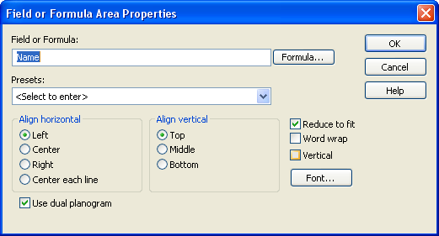

AND…

The “use dual planogram” checkbox is on every layout Area type where content can be planogram-specific.   From my PPTX it’s the circled area types:

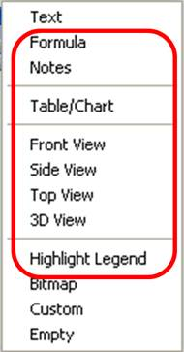

*Curtis*